

Michael Ragsdale

Old Dominion University

IDS 300W

Dr. LaFever

July 20th, 2024

Legal and Limitation Questions for Using AI to Create Web Pages

© 2024 Michael Ragsdale. AI Art Generated using Microsoft Designer.   
<https://michaelpragsdale.com/ai-paper/> • [mrags002@odu.edu](mailto:mrags002@odu.edu)

Table of Contents

View this as a Web Site II

Abstract III

Research Question IV

What does Interdisciplinary Studies Mean? 1

Ten Steps to the Interdisciplinary Research Process 1

Define the Problem 2

Justify Your Problem 2

Identify Relevant Disciplines 3

Conduct Your Research 4

Develop Adequacy in Relevant Disciplines 5

Analyze and Evaluate Each Theory 5

Identify Conflicts 5

Create a Common Ground 6

Construct a Comprehensive Understanding 6

Reflect and Test the Understanding 6

What is AI? 6

Questioning the Copyright Ownership of AI 8

Authorship 9

Ownership 10

Liability 11

Legal Question Concerning Websites 12

Graphics Design and the Law 12

AI and its Limitations 13

Explainability of AI 13

Robustness 15

Limitations Concerning Websites 15

Conclusion 16

References 17

# View this as a Web Site

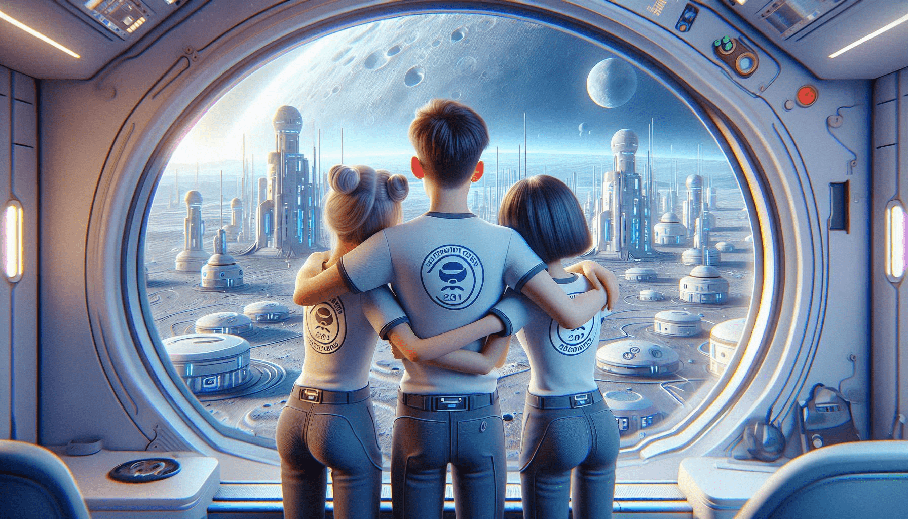

My skills are that of website creation, with a specialty of making websites that are responsive, dark mode friendly, and Section 508 compliant. To see this document as I intended, please visit <https://michaelpragsdale.com/ai-paper/>. This is what I intend to do when I finally receive this degree five years after the University let me participate in Spring 2019 ceremony.

# Abstract

This paper examines the main challenges and implications of artificial intelligence (AI) from a legal and ethical perspective, focusing on the questions of copyright, accuracy, authorship, ownership, liability, explainability, and robustness. The paper provides an overview of the definitions and applications of AI, such as generative AI, and the potential benefits and risks of AI for human society. The paper also discusses some of the workable solutions and directions for future research and regulation of AI systems, such as consulting legal counsel, adopting different models and theories of liability, and ensuring the transparency and accountability of AI systems. The paper concludes by highlighting the need to balance the rights and interests of the AI creators, users, and agents, as well as the human authors, inventors, and collaborators, and the third-party beneficiaries, licensees, and infringers, and to develop and implement AI systems that are beneficial and responsible for humanity.

This paper also discusses the use of interdisciplinary studies and the use of AI to create webpages. It explores the potential benefits and challenges of using AI in web development, including the ethical and practical questions surrounding the legality and accuracy of the generated content. The paper also delves into the limitations of AI and the questions of copyright ownership, authorship, and liability of AI-generated works.

*Keywords: AI, Authorship, Copyright, Ethical Implication, Explainability, Graphics Design, Liability, Limitations, Ownership, Robustness, Webpages*

# Research Question

What are the major challenges of integrating Artificial Intelligence in Web Design?

# What does Interdisciplinary Studies Mean?

Interdisciplinary studies are an approach to learning that integrates knowledge and methods from different disciplines, such as science, technology, arts, and humanities. Interdisciplinary studies can help students develop critical thinking, creativity, and problem-solving skills, as well as foster a broader perspective on complex issues. One of the emerging fields of interdisciplinary stu (Repko & Szostak, 2021), such as understanding natural language, recognizing images, or generating content. AI can be used to create webpages that are responsive, personalized, and engaging, without requiring much human input or coding. However, the use of AI to create webpages also raises some ethical and practical questions, such as the legality and accuracy of the generated content.

# Ten Steps to the Interdisciplinary Research Process

The ten steps to the interdisciplinary process embrace a shared understanding on how to engage in an interdisciplinary setting that will be useful in addressing current and future grand challenges (Kelly, 2019). As an example from the textbook, “When driving to an unfamiliar place away from home, travelers rely on Global Positioning System (GPS) to avoid unproductive, time-consuming detours. Similarly, when proceeding from a problem to an understanding of the problem, interdisciplinarians need a map to guide them through the interdisciplinary research process or IRP (Repko & Szostak, 2021).”

## Person standing next to her brother, who is sitting at a computer doing homework. She is tutoring him.Define the Problem

Figure 1: Sister tutoring her brother on the Ten Steps of the Interdisciplinary Process

This is the step that often takes the most time and effort. You are identifying a complex, researchable problem or question. The problem must include at least two disciplines to be considered interdisciplinary (Coleman, 2022).

We can use this process and apply it to AI and websites. As this author wrote in *Writing Workshop 1*, “In fact, the web page you are viewing that comprises this assignment is based on knowing the different pieces. Knowing how to write code is great, but someone also needs to know how to create graphics. An example would be the background you are currently looking at, where our student is on the computer brainstorming ideas for his assignment, and his older sister is at his side to bounce ideas off of. For coding: as part of my work at what was then ODU’s Center for Learning and Teaching, I was the one primarily responsible for making sure that Canvas — and PLE before it — met the accessibility requirements of students of all abilities. It is the skill of combining both disciplines that allows me to be a better person to craft websites that meet the needs of anyone who wishes to view them. The discipline of writing is necessary because the page needs to be readable without spelling and grammar errors. A website is nothing if there are errors that stick out like sore thumbs (Ragsdale, 2024).”

## Justify Your Problem

Justify your problem or question using an interdisciplinary approach. Ensure your problem is complex, involving 2 or more disciplines, and has not yet been resolved (Coleman, 2022).

As the author continued in *Writing Workshop 1*, “Why do we combine disciplines? The justification for combining disciplines is that each has their own strengths that can add to the project. As an example, I’m not very good at creating graphics (the background images were crafted using The Sims 4), and I would want to turn to others to help projects along. This webpage uses tools built by others to ensure it can look its best, and these other people have a range of different disciplines. This ensures that the best minds work on the parts that they can do best. For example, I can write the code, while the graphics wizards at Electronic Arts create the style of artwork that I will use to create characters in The Sims 4 (Ragsdale, 2024).”

## Identify Relevant Disciplines

Based on the question you have created, identify the relevant disciplines that could be tied together with your question. Look at all angels and different view points (Coleman, 2022).

Continuing with *Writing Workshop 1*, “ow that there is a problem to solve, it is time to see what disciplines can be used. Computer Science is absolutely a great place to start. Websites need to be coded after all. This in of itself combines a range of skills: HTML, CSS, JavaScript, etc that all fall under the guise of coding. Next up, we need to add in a little bit of artistry. Coding is great when it comes to powering a website, but it also needs to look great. Knowing your way around GIMP, Paint.NET, or other tools is essential. No one is going to want to visit your website if it does not look its best. This little tour of disciplines will wrap up with language arts. You have the code. You have the graphics. Do you have properly formed words and paragraphs? Typically, writing involves tools like Microsoft Word, but HTML is nothing more than plain text. Typically, especially for larger company websites (and even the Canvas editor we are using to submit our assignments), copying from Word can be difficult to the point where you might as well type plain text into the editor and not have access to F7 (Ragsdale, 2024).”

## Conduct Your Research

Now that you have identified the disciplines you will focus on, now you will start your literature research. reviewing relevant articles, blogs, websites, and books on your topics (Coleman, 2022).

“Creating websites is not too terribly difficult. Learning the code that powers websites - even something as simple as this assignment - is available even at the public-school level. However, getting deeper into the topic and allowing for details that seem like a lot (see what I did on Discussion #2 to pretty it up).

What kind of research can we do? Stack Overflow is your best friend, as it answers most of the technical questions someone might have with creating websites. Another great resource is LinkedIn Learning which is paid for by Old Dominion University. In this field, there is not much in the way of Google Scholar or Monarch OneSearch (or the Card Catalog for us old timers).

There are numerous websites that are just a search away that will provide the help you need to get going with your creations. The websites that help with writing that is used for this class is a good example, as you will usually not have access to spell checking and grammar checking when using a code editor. There are also websites that provide you with help in using your favorite graphics tool (and not just Adobe Photoshop but free tools as well such as GIMP among other tools (Ragsdale, 2024).”

## Develop Adequacy in Relevant Disciplines

Find explanations in all of your relevant disciplines and show how each discipline can be tied together to explain your question (Coleman, 2022).

“Practice makes perfect. Learn how to write the code, learn how to create and/or manipulate images in the editor of your choice, and learn how to write without the aid of spell and grammar checking. Visual Studio Code, the editor I used to create this file, can have a spelling checker as an extension. However, these tools are not as powerful as the checker included with Microsoft Word (Ragsdale, 2024).”

## Analyze and Evaluate Each Theory

Evaluate each insight or theory that could correlate with your question or problem. Create your own theory and insights to evaluate as well (Coleman, 2022).

“Combining code with graphics seems easy, but there are several ways to do it. The background images are loaded via CSS and foreground images are loaded by the image tag. For writing: do you want to write in Word and have to fix Word’s attempt to pretty up the text but have an advanced spelling and grammar checker, or do you want to use an HTML editor and deal with the spelling and grammar yourself (Ragsdale, 2024)?”

## Identify Conflicts

Identify conflicts between insights and theories. Find where they disagree in your research and elaborate on how they could look past these to formulate a solution (Coleman, 2022).

Do you want to edit code by hand, or do you want a *What You See is What You Get (WYSIWYG)* editor (Ragsdale, 2024)?

## Create a Common Ground

Discover a common ground between all of your disciplines and where they could come together to format a new insight or theory (Coleman, 2022).

“The correct answer, at least for me? Editing straight code. WYSIWYG editors often produce more code than is what is absolutely needed, therefore slowing down the site (Ragsdale, 2024).”

## Construct a Comprehensive Understanding

Using all that you have found in similarities and differences between your disciplines, formulate a comprehensive understanding of your findings (Coleman, 2022).

“With all of that out of the way, let’s put the three different skillsets together. What do you need to know? What do you already know (Ragsdale, 2024)?”

## Reflect and Test the Understanding

Reflect on your understanding and research. Conduct any test to prove your theory or test a prototype of a device create (Coleman, 2022).

“Now, you will be able to build a website that works great, and you will understand how to take care of all of the needs of the end-product. In the end, this will make you more valuable for potential employers (Ragsdale, 2024).” This completes the ten steps of the interdisciplinary process. Now, how does this connect with AI and the law?

# What is AI?

Artificial intelligence, or AI, is the new kid on the block. As of 2023, it is starting to become more widely available for the personal end-user. Examples of AI included in this document, starting with the AI generated image used as the cover page for this document. So, what is AI? Asking Microsoft Copilot to generate a college level prompt for “What is AI” produced this result.

“Artificial intelligence (AI) is a branch of computer science that aims to create machines and systems that can perform tasks that normally require human intelligence, such as reasoning, learning, decision making, perception, and natural language processing. AI is a broad and interdisciplinary field that draws from various disciplines, such as mathematics, logic, philosophy, psychology, neuroscience, engineering, and statistics. AI can be classified into two main categories: narrow AI and general AI. Narrow AI refers to systems that can perform specific tasks, such as face recognition, speech recognition, chess playing, or self-driving cars. General AI refers to systems that can exhibit human-like intelligence across a wide range of domains, such as common sense, creativity, and social skills. General AI is still a hypothetical and elusive goal, while narrow AI has achieved remarkable progress and applications in recent years.”

This is a fitting example of what AI is, and it also brings up a great pointer: what are the limitations of AI? In this example, I asked it to provide cited sources and it did not, let alone offer sources in the APA format. This also brings up the question of copyright. Who wrote the text in this answer? Who gets credit for it? There is no way for me to know.

# Questioning the Copyright Ownership of AI

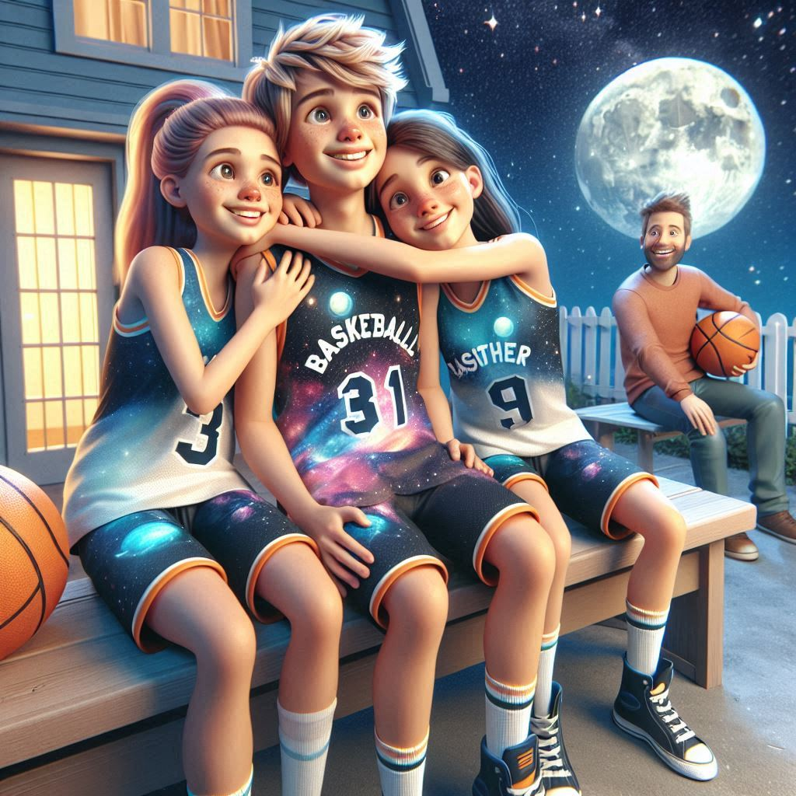AI seems like it could be the answer to everything to the untrained eye. To quote Harvard Business Review, “Generative AI can seem like magic (Gil Appel, 2023).” As an example, I do not have the skillset to draw an image such as the one seen here where three siblings Aubrie, David, and Shannon just finished a game of basketball in their backyard. While this image does seem polished, there seems to be a question of who owns it.

Figure 2: Aubrie, David, and Shannon after a round of backyard basketball. Who owns the rights to this image?

This image was created using Microsoft Designer and, according to Section 2(C) of the terms of use, “Microsoft strongly recommends consulting legal counsel regarding any use You intend to make of the Creations.” Meanwhile, Section 5 states **“Use of Images**. Subject to your compliance with (i) this Agreement (and subject to the limitations in Paragraphs 1, 2, and 6) and (ii) the Microsoft Services Agreement, including the Code of Conduct, you may use Creations for any legal purpose (Microsoft, 2023).”

Therefore, the tool itself raises the question of who owns the copyright. While it appears that I own the rights to the images, Microsoft strongly suggests that I get legal advice before using these images. According to Harvard Business Review, “This process comes with legal risks, including intellectual property infringement. In many cases, it also poses legal questions that are still being resolved. For example, does copyright, patent, trademark infringement apply to AI creations? Is it clear who owns the content that generative AI platforms create for you, or your customers (Gil Appel, 2023)?” This aligns with the concepts brought up in the Microsoft Designer terms of use of “it’s yours but consult legal counsel just in case.”

According to the U.S. Copyright Office, a work of authorship is protected by copyright if it is original and fixed in a tangible medium of expression. However, the Office also states that “copyright law does not protect ideas, methods, or systems (United States Copyright Office).” Therefore, the question is whether the content created by AI is original and fixed, or whether it is derived from existing sources and not fixed in a tangible medium. For example, if an AI system uses natural language processing (NLP) to analyze and summarize information from various websites and generate a webpage, is the webpage original and fixed, or is it a derivative work of the original sources? Furthermore, who owns the rights to the webpage: the AI system, the developer of the AI system, the user of the AI system, or the original sources?

There is no clear answer to these questions, as the current legal framework does not adequately address the role and status of AI in the creative process. Some scholars have suggested that AI-generated content should be considered as a joint work of the AI system and the human collaborators, and that the rights should be shared accordingly (Abbott, 2016).

## Authorship

One of the key questions of AI is the authorship or attribution problem, which refers to the difficulty of identifying and recognizing the creator or contributor of an AI-generated work or invention, especially when the AI system is autonomous, creative, or collaborative. Authorship is important for several reasons, such as acknowledging the originality, creativity, and contribution of the work or invention, protecting the moral and economic rights and interests of the author or inventor, and incentivizing the innovation and dissemination of the work or invention (Abbott, 2016).

However, authorship is not a straightforward or consistent concept, as different criteria and standards of authorship may exist, depending on the type, domain, and jurisdiction of the work or invention. Moreover, authorship may also involve multiple and complex factors, such as the role, input, and output of the AI system, the human involvement and intervention in the AI system, and the intention, expectation, and agreement of the AI creator, user, and agent. Therefore, there is no clear or universal solution for authorship, and different arguments and positions may be adopted for different situations and applications (Abbott, 2016).

## Ownership

A related question of AI is the ownership or allocation problem, which refers to the difficulty of determining and assigning the rights and interests of an AI-generated work or invention, especially when the AI system is autonomous, creative, or collaborative. Ownership is important for several reasons, such as securing the legal and economic benefits and obligations of the work or invention, regulating the access, use, and distribution of the work or invention, and resolving the conflicts, disputes, or infringements of the work or invention (Abbott, 2016).

However, ownership is not a simple or uniform concept, as several types and levels of ownership may exist, depending on the nature, domain, and jurisdiction of the work or invention. Moreover, ownership may also involve multiple and complex parties, such as the AI creator, user, agent, or system, the human author, inventor, or collaborator, and the third-party beneficiary, licensee, or infringer. Therefore, there is no obvious or optimal solution for ownership, and different rules and principles may be applied for different situations and applications (Abbott, 2016).

## Liability

A third question of AI is the liability or responsibility problem, which refers to the difficulty of identifying and attributing the fault or harm of an AI-generated work or invention, especially when the AI system is autonomous, creative, or collaborative. Liability is important for several reasons, such as compensating the damages or losses of the work or invention, correcting the errors or failures of the work or invention, and preventing or deterring the misuse or abuse of the work or invention (Abbott, 2016).

However, liability is not a fixed or consistent concept, as distinct types and degrees of liability may exist, depending on the cause, effect, and jurisdiction of the work or invention. Moreover, liability may also involve multiple and complex parties, such as the AI creator, user, agent, or system, the human author, inventor, or collaborator, and the third-party victim, plaintiff, or defendant. Therefore, there is no definite or general solution for liability, and different theories and models may be adopted for different situations and applications (Abbott, 2016).

Some of the possible approaches and models for addressing the liability of AI-generated works or inventions include the following potential solutions. Imposing or allocating the liability to the AI creator, user, or agent, such as applying the negligence, strict liability, or vicarious liability theories, or the product liability, tort liability, or contract liability models. Another option is to impose or allocate the liability to the human author, inventor, or collaborator, such as applying the contributory negligence, joint liability, or shared liability theories, or the infringement liability, malpractice liability, or negligence liability models. Lastly, an option is to reduce or share the liability of the AI system, such as applying the contributory fault, comparative fault, or proportional fault theories, or the insurance, indemnity, or fund models (Abbott, 2016).

## Legal Question Concerning Websites

A legal question of AI with constructing websites is the legal challenges of regulating and governing the use of AI systems. AI systems may not comply with the existing laws, regulations, or standards that apply to web development, such as copyright, intellectual property, data protection, consumer protection, or accessibility. For example, AI systems may generate or use content that infringes on the rights of the original creators or owners, or that violates the privacy or consent of the data subjects. AI systems may also create or use content that is inappropriate, offensive, or harmful, or that incites violence, hatred, or discrimination. Furthermore, AI systems may not meet the requirements or expectations of the web users or stakeholders, such as usability, reliability, security, or quality (Floridi, et al., 2018).

## Graphics Design and the Law

Graphics design and the law are two disciplines that have a significant impact on how people perceive and interact with the world. Graphics design and the law both use visual and verbal elements to communicate messages, persuade audiences, and influence behavior. Graphics design can help the law in various ways, such as simplifying legal information, enhancing legal education, improving legal branding, and supporting legal advocacy. The law can also help graphics design by protecting its intellectual property, ensuring its quality, regulating its ethics, and promoting its diversity. Together, they can create a more accessible, effective, and inclusive legal system (Haapio & Passera, 2013). This needs to be taken into consideration when using AI trained graphics in documents. This includes the images embedded into this document, since there are legal questions as to the source of them.

# AI and its Limitations

|  |  |  |
| --- | --- | --- |
| A person in a wheelchair next to a bus  Figure 3: David is discharged from the hospital and Aubrie and Shannon need to get him home | A group of people pushing a person in a wheelchair  Figure 4: The three siblings are at the Downtown Transportation Center. This #45 is supposed to be the same vehicle as the #2 in the previous image | A group of people pushing a person in a wheelchair  Figure 5: The #3 is their ride back to their house, and is supposed to be a different vehicle but at the same Downtown Transportation Center as the previous image |

The three characters across the images are supposed to be the same people, and the #2 and #45 buses are supposed to be the same vehicle. The #45 and #3 are supposed to be at the same Downtown Transportation Center. This is a limitation of using Microsoft Designer as an AI generator: it does not remember what things look like across scenes.

AI can be a great tool when generating content, but it is not perfect. As seen in these three images, it is attempting to have three characters and tell a story of them moving between three different city bus routes. However, you will notice that they look different in every image. This is because AI is just that: artificial. In the case of Microsoft Designer, it does not remember what it drew across prompts, and therefore changes the characters each time.

## Explainability of AI

One of the key challenges of AI is the explainability or interpretability problem, which refers to the difficulty of understanding how and why an AI system makes a certain decision or prediction, especially when the system is based on complex and opaque algorithms, such as deep neural networks. Explainability is important for several reasons, such as ensuring the validity, accuracy, and reliability of AI systems, enhancing the trust and confidence of users and stakeholders, facilitating the debugging and improvement of AI systems, and complying with the ethical and legal requirements of transparency and accountability (Alejandro Barredo Arrieta, 2020).

However, explainability is often at odds with the performance and accuracy of AI systems, as the more complex and sophisticated an AI system is, the harder it is to explain its inner workings and logic. Moreover, explainability is also context-dependent and user-dependent, as different users and stakeholders may have different expectations and needs for explanations, depending on their goals, backgrounds, and levels of expertise. Therefore, there is no one-size-fits-all solution for explainability, and different approaches and techniques may be needed for different scenarios and applications (Miller, 2019).

As an example of the question of why AI makes the decisions that it makes: consider this image of our three siblings in front of a college building. I asked in the AI prompt for it to be a warm summer day, as this is supposed to be the first day of school, which in Virginia means that it is usually hot and miserable out. In my prompt, I told the system that I wanted them to wear jean shorts and t-shirts, but that tripped up the Microsoft Responsible AI Guidelines filter. That is, the filter that tries to stop those with bad intentions from making questionable images (i.e., deepfake porn). I removed the word shorts, and Microsoft Designer produced the image seen here. Note how Aubrie, as well as some of the background people in the scene are wearing a sweatshirt on the first day of school, on what in Virginia would typically be a hot, miserable day. Notice also in the background that some of the trees are already changing color, even though autumn should not have begun yet.

Figure 6 Left to Right: Shannon, Aubrie, and David on their first day of college. Note how there are fall/winter clothes on typically what would be (in Virginia) a sizzling summer day.

## Robustness

Another major challenge of AI is the robustness or reliability problem, which refers to the vulnerability of AI systems to errors, failures, or attacks, especially when the systems are exposed to novel, noisy, or adversarial inputs or environments. Robustness is essential for ensuring the safety, security, and quality of AI systems, as well as preventing or minimizing the potential harm or damages to users and society. Robustness is also related to the technical and operational requirements of accuracy, consistency, and resilience, as well as the ethical and legal principles of responsibility and liability (Hendrycks & Dietterich, 2019).

However, robustness is often challenging to achieve and maintain, as AI systems may face various sources and types of uncertainty, variability, or adversarial, such as data noise, distribution shift, model drift, or malicious attacks. Moreover, robustness may also depend on the context, domain, and task, as various levels and aspects of robustness may be needed or expected, depending on the complexity, criticality, and sensitivity of the application. Therefore, there is no single or general solution for robustness, and different methods and strategies may be needed for different scenarios and applications (Hendrycks & Dietterich, 2019).

## Limitations Concerning Websites

One of the major limitations of AI with constructing websites is the ethical implications of using algorithms to make decisions that affect human lives. AI systems may not always align with human values, morals, or preferences, and may cause unintended consequences or harm. For example, AI systems may generate biased, inaccurate, or misleading content for websites, based on the data they are trained on or the objectives they are optimized for. This may violate the principles of fairness, accountability, transparency, and privacy, and may harm the reputation, trust, or credibility of the website owners or users. Moreover, AI systems may not be able to explain or justify their decisions or actions, making it difficult to hold them accountable or responsible for their outcomes (Russell, Dewey, & Tegmark, 2015).

# Conclusion

AI is a rapidly evolving and expanding field that has tremendous potential and benefits for human society, but also poses significant challenges and risks that need to be addressed and managed. In this paper, we have provided an overview of the main challenges and implications of AI, focusing on the limitations of AI as well as the copyright questions of AI. We have discussed some of the workable solutions and directions for future research, but we acknowledge that these are not exhaustive or conclusive, and that more work and dialogue are needed to explore and resolve the complex and novel issues of AI.

As AI becomes more ubiquitous and influential in our lives, we need to ensure that AI systems are not only intelligent and efficient, but also explainable, fair, robust, ethical, and legal. We also need to balance the rights and interests of the AI creators, users, and agents, as well as the human authors, inventors, and collaborators, and the third-party beneficiaries, licensees, and infringers. We hope that this paper can contribute to the ongoing and future discussions and debates on the challenges and implications of AI, and that it can inspire and inform the development and regulation of AI systems that are beneficial and responsible for humanity.

# References

Abbott, R. (2016, September 28). *I Think, Therefore I Invent: Creative Computers and the Future of Patent Law*. Retrieved from Boston College Law Review: https://bclawreview.bc.edu/articles/566

Alejandro Barredo Arrieta, N. D.-R.-L. (2020). Explainable Artificial Intelligence (XAI): Concepts, taxonomies, opportunities and challenges toward responsible AI. *Information Fusion*, 82-115. doi:https://doi.org/10.1016/j.inffus.2019.12.012

Coleman, M. (2022, December). *10 Step Interdisciplinary Research Process.* Retrieved July 16, 2024, from Old Dominion University: https://sites.wp.odu.edu/wp-content/uploads/sites/30242/2022/12/Mackenzie-Coleman-Workshop-1.pdf

Floridi, L., Cowls, J., Beltrametti, M., Chatila, R., Chazerand, P., Dignum, V., . . . Vayena, E. (2018, November 26). AI4People—An Ethical Framework for a Good AI Society: Opportunities, Risks, Principles, and Recommendations. *Minds & Machines, 28*, 689-707. doi:https://doi.org/10.1007/s11023-018-9482-5

Gil Appel, J. N. (2023, April 7). *Generative AI Has an Intellectual Property Problem*. Retrieved from Harvard Business Review: https://hbr.org/2023/04/generative-ai-has-an-intellectual-property-problem

Haapio, H., & Passera, S. (2013, May 15). *Visual Law: What Lawyers Need to Learn from Information Designers.* Retrieved July 15, 2024, from VOXPOPULII (Cornell Legal Information Institute): https://blog.law.cornell.edu/voxpop/2013/05/15/visual-law-what-lawyers-need-to-learn-from-information-designers/

Hendrycks, D., & Dietterich, T. (2019). *Benchmarking Neural Network Robustness to Common Corruptions and Perturbations.* Cornell University. March. doi:https://doi.org/10.48550/arXiv.1903.12261

Kelly, R. (2019, October 1). *10 tips for next generation interdisciplinary research*. Retrieved July 16, 2024, from Integration and Implementation Insights: https://i2insights.org/2019/10/01/10-tips-for-interdisciplinary-research/

Microsoft. (2023, October 25). *Designer for Web Image Generator and Brand Kit Terms Preview.* Retrieved July 15, 2024, from Microsoft Designer: https://designer.microsoft.com/termsOfUse.pdf

Miller, T. (2019). Explanation in artificial intelligence: Insights from the social science. *Artificial Intelligence*, 1-38. doi:https://doi.org/10.1016/j.artint.2018.07.007

Ragsdale, M. (2024, May 27). *The Ten Steps of the Interdisciplinarity Research Process*. Retrieved July 16, 2024, from Michael Ragsdale's Portfolio: https://michaelpragsdale.com/samples/school-work/odu/ids300w/files/writing-workshop-01/

Repko, A. F., & Szostak, R. (2021). *Interdisciplinary Research Process and Theory (4th Edition).* Los Angeles: Sage Publishing.

Russell, S., Dewey, D., & Tegmark, M. (2015, December 15). *Research Priorities for Robust and Beneficial Artificial Intelligence*. doi:https://doi.org/10.1609/aimag.v36i4.2577

United States Copyright Office. (n.d.). *United States Copyright Office.* Retrieved July 15, 2024, from What Does Copyright Protect?: https://www.copyright.gov/help/faq/faq-protect.html